Our Mission
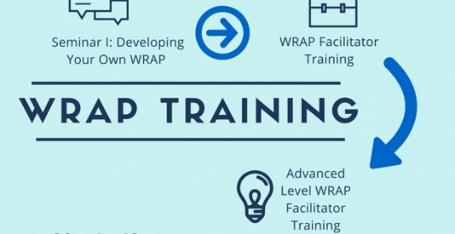
We teach mental health recovery skills including Wellness Recovery Action Planning to people who experience psychiatric symptoms, their family members and health care providers. Each of our facilitators has fulfilled the qualifications as a Mental Health Recovery Educator and has a Mental Health Recovery Educator Certificate.

​As Certified Educator/Facilitators we are committed to the following model work with people who have experienced psychiatric symptoms to discover the strengths they have and can use to enhance their recovery; effectively share the underlying concepts necessary to recovery: hope, personal responsibility, education, self-advocacy, and support; work with individuals and groups to develop a Wellness Recovery Action Plan (WRAP), a symptom monitoring and response system being used all over the world; teach about wellness tools and strategies, such as medication management, changing negative thoughts to positive, and developing a wellness lifestyle; empower and motivate people to work toward recovery - feeling the way they want to feel, making their lives the way they want them to be, and moving toward meeting their life goals; use interaction and presentation styles and strategies that enhance recovery.

