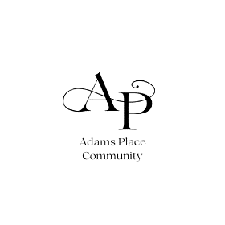
Message: what committees are needed on a community action board. The specific committees needed by a community action board will vary depending on the size and scope of the organization, as well as the needs of the community it serves.
However, some common committees include:

Executive Committee: This committee is responsible for overseeing the day-to-day operations of the board and making decisions between full board meetings.

Finance Committee: This committee is responsible for developing and monitoring the board's budget, as well as overseeing its financial investments.

Governance Committee: This committee is responsible for developing and reviewing the board's bylaws and policies, as well as ensuring that the board is complying with all applicable laws and regulations. Image of

Program Committee: This committee is responsible for developing and overseeing the board's programs and services.

Development Committee: This committee is responsible for fundraising and development activities.

Nominating Committee: This committee is responsible for identifying and nominating candidates for the board of directors.

Consumer Advisory Committee: This committee is made up of low-income community members who provide feedback on the board's programs and services.
In addition to these standing committees, community action boards may also form ad hoc committees to address specific issues or projects.

