Wrap Seminar I: Developing a Wellness Recovery Action Plan®

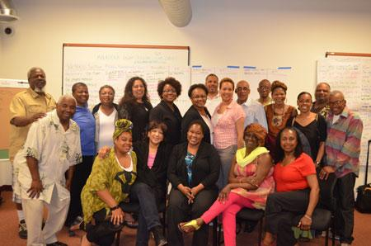

Course Description: WRAP Seminar I is offered in several workshops depending on the number of participants. This course is for anyone who wants to learn about the WRAP® and begin to incorporate it into their life to improve personal wellness and achieve an improved quality of life. These workshops are designed to be highly interactive and encourage participation and sharing from all present. This workshop also lays a broad foundation for building a peer workforce.

This Class Fulfills the Prerequisites for WRAP Facilitator Training

Learning Objectives

Through Participation in these workshops people will be able to:
- Apply Key Concepts of Recovery into their everyday life to improve their quality of life.
- Identify tools and action plans to counter the negative effects of life challenges and improve responses to disturbing thoughts and feelings to achieve improved states of wellness.
- Describe the history, foundations and structure of the Wellness Recovery Action Plan®.
Mental Health Recovery
Including
Wellness Recovery Action Planning (WRAP)

A workshop for people who experience mental health challenges and for those who care about them

TOPICS INCLUDE:

- Empowerment & Responsibility
- Developing a Wellness Recovery Action Plan
- Diet, Light & Exercise
- Preventing & Avoiding Suicide
- Stress Reduction & Relaxation Methods
- Developing & Keeping Support Systems
- The Importance of Education
- Taking Preventative Action Early
- Changing Negative Thoughts to Positive Ones
- Taking Responsibility for Wellness
- Building Self-Esteem & Self-Confidence
- Peer Counseling

Copyright Mary Ellen Copeland - All Rights Reserved - www.mentalhealthrecovery.com

WRAP®: Wellness Recovery Action Plan Overview

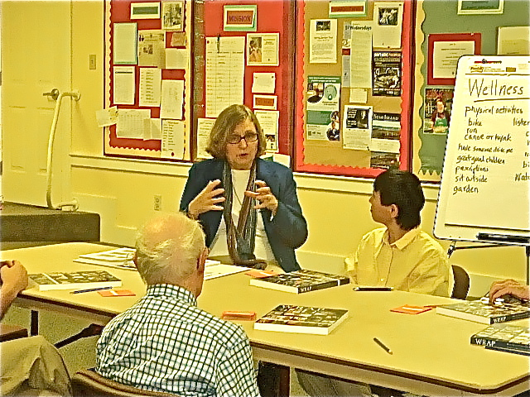
WRAP is a self-designed plan for staying well and for helping you to feel better when you are not feeling well, to increase personal responsibility, and to improve your quality of life.

The WRAP approach empowers you to take control of your own health and wellness.

Since its development, the system has been shared with hundreds of thousands of people through the Wellness Recovery Action Plan books: WRAP Plus, the Living WRAP video, the Creating Wellness Video series, Build Your Own WRAP and other online courses, numerous support groups, workshops and seminars, and through this web site.

With WRAP, people who experience mental health and other health challenges no longer feel that they are sentenced to a life of chronic disability that interferes with their ability to work toward and reach their goals. Instead, by using self-help skills and strategies that complement other treatment scenarios, they are achieving levels of wellness, stability, and recovery they always hoped were possible.

WRAP stands for Wellness Recovery Action Plan
There are four parts to the study of mental health recovery and wrap that we will be learning about:
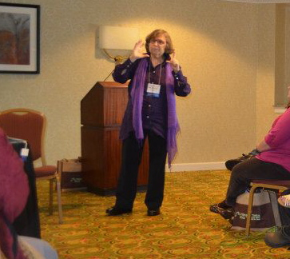
- The Five Key Concepts
- Hope
- Personal Responsibility
- Education
- Self-Advocacy
- Support
… and issues that need attention:
- getting good health care
- medication management

- The Wellness Toolbox
- The Wellness Recovery Action Plan:
    - Daily Maintenance Plan
    - Triggers & Triggers Action Plan
    - Early Warning Signs & Early Warning Sign Action Plan
    - When Things Are Breaking Down & When Things Are Breaking Down Action Plan
    - Crisis Plan
    - Post Crisis Plan
4. The Recovery Topics:
    - Building Self-Esteem
    - Changing Negative Thoughts to Positive Ones
    - Peer Support
    - Work Related Issues
    - Trauma Recovery
    - Suicide Prevention
Additional Issues
- Living Space
- Lifestyle
- Motivation
Session 1
Introduction to Key Concepts and WRAP®
Agenda

Welcome, Housekeeping, & Ice-Breaker 20 minutes
Review workshop series agenda 10 minutes
Develop participant guidelines 15 minutes
Key concepts:
Hope, Personal Responsibility, Education 20 minutes
Break 10 minutes
Key concepts: Self-Advocacy, Support 60 minutes
Introduction to WRAP 10 minutes
Review & Closing 5 minutes
Session 1 Goal
During this session, facilitators and participants will become acquainted, they will develop guidelines for safe and respectful interactions within the group, and they will review the plans for the week. Participants will begin to learn about key recovery concepts that are the foundation of WRAP. They also will receive a brief introduction to WRAP.
Note: Handouts on pages 3-1 to 3-27 can be copied and given to the participants. This section also includes ideas for related activities that may be helpful to your group. You can also give the participants copies of the thumbnail sketches of the slides (Section 2, pages 1-14).

WRAP Seminar I: Developing a Wellness Recovery Action Plan (WRAP)
~
Creating a Supportive Learning Environment

In our WRAP Group we all want everyone to learn about Wellness Recovery Action Planning (WRAP) and how to incorporate WRAP into our own lives.
We want to use Wellness Recovery Action Planning (WRAP) to:
- Improve personal wellness and
- Achieve an improved quality of life.

My WRAP Group / Workshop Daily Maintenance Plan
~
(Wellness Toolbox)

- I Will Support Myself Today By:

- Stick to the agenda
- Write in my journal
- Stay focus on finding a place to live

WRAP Seminar I: Developing a Wellness Recovery Action Plan
Participants Discussion Guide
Session One

Support

Discuss:

- What are some things that you or others might do that keep you from getting to know someone else better or spending time with them?

- What activities in the community have you considered attending but have never gone?

- Have you attended a community activity and met a new friend or friends? If so, describe.

- What would make it easier for you to attend a community activity for the first time?

- What volunteer opportunities are there to make new friends and supporters?

- What are some activities you enjoy with friends?

- What could you do for a friend who doesn’t ask as much of you as you ask of them?

- Describe other ways you could enhance your family’s support?

- Why is it important to have “natural supports”? (Natural supports are people who are not health care providers)

