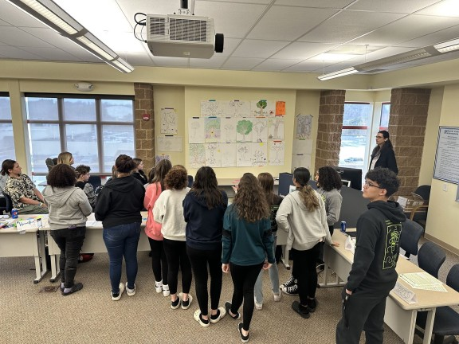
Taking Action for Whole Health and Wellbeing
The Copeland Center’s Taking Action for Whole Health & Wellbeing course is a co-facilitated group process that supports individuals in creating a personalized system for recovering, sustaining, and/or improving their whole health outcomes and enhancing their lifestyle.

The curriculum is based on the US Substance Abuse and Mental Health Administration’s (SAMHSA) Taking Action curriculum and other recovery publications developed with input from individuals with lived experience of recovery from mental health, addictions, and co-occurring challenges.
The topics, practices, and approaches in this program have demonstrated effectiveness through various research studies and with input from care providers.
The Copeland Center’s Taking Action for Whole Health & Wellbeing program combines key curriculum topics with evidence-based and experiential-based peer-to-peer strategies.
Taking Action for Whole Health and Wellbeing is a curriculum led by two peer co-facilitators trained in the Copeland Center’s process for evidence-based, and experiential-based peer strategies.
Co-facilitator’s training incorporates over two decades of peer-based experience and evidenced-based engagement strategies such as Self-Directed Care, Wellness Self-management, Motivation Theory, and Peer Support.

Essential Elements:
- Recovery, wellness, and action orientation
- Focus on hope, empowerment, self-determination, education, community inclusion and self-advocacy.
- Building a Strong Support System
- Personal and Community Resources

- Wellness tools, skills, and strategies for whole health and wellbeing
- Physical Health and the effects of exercise, nutrition, light, sleep, and smoking
- Finalizing Wellness Tools: Spirituality, Complementary, Controversial, Alternative and Additional tools
- Developing Action Plans for Triggers, Early Warning Signs, Difficult Times

- Healthcare and medications
- Crisis Planning and Advanced Directives
- Post Crisis and Post Relapse planning.
- Wellness Topic: Employment, Meaningful Activity, Motivation and Lifestyle
The curriculum can be delivered by covering the Key Essential Elements over at least 20 hours via three full-day retreats or multiple sessions of at least 2.5 hours each based on a group between 12-18 participants.
Adequate time is needed to allow space for the experiential engagement of all participants.
Key essential elements are the active ingredients of our evidence-based strategies.
An expanded and enhanced program includes up to 24 module sessions intended to be provided for individuals over an extended period.
Taking Action for Whole Health & Wellbeing and this co-facilitation training is designed with the experience and collective knowledge of people who have been working together to achieve recovery and wellness for over two decades to share their personal expertise in dealing with and overcoming many health and overall life challenges.
We have developed this work with over two decades of input from co-facilitators working together from around the world.
The Copeland Center for Wellness & Recovery works to listen to and include the input of every member in these courses.
The experiential sharing that we do continues to grow and improve upon this wellness and recovery knowledge and co-facilitation approaches to this work.
Taking Action for Whole Health & Wellbeing and the co-facilitation training is designed with the experience and collective knowledge of people who have been working together to achieve recovery and wellness for over two decades.
We work in these courses to share our personal expertise in dealing with and overcoming a diversity of health and overall life challenges.
We have developed this work through the input from co-facilitators working together from around the world for over two decades.

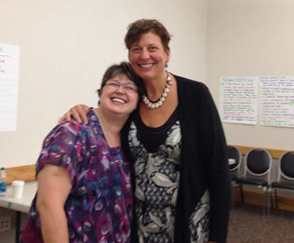
Taking Action Co-Facilitator Training
Course Description:

This course is 4-5 intensive days of workshops that will prepare participants to co facilitate workshops based on SAMHSA's Taking Acton Program and acquire the skills, knowledge, and materials to co-facilitate groups in their community and organization.

It is for people who have completed a Taking Action course.

The Taking Action Co-Facilitator training provides an experiential learning environment based on mutuality, empowerment, connection, and self-determination.

Participants in this course will be expected to participate in interactive learning activities and demonstrate their own experience with the Taking Action Program.

This training is appropriate for anyone who would like to lead wellness and recovery groups, work with others to develop their steps to taking action for wellness and recovery and give presentations on mental health wellness and recovery-related issues to groups or organizations.
Participants are expected to have a solid working knowledge of the Taking Action Program and share their experiential knowledge of how taking action for wellness and recovery has worked.

Wellbeing Mentors Course
AUDIENCE: Facilitator

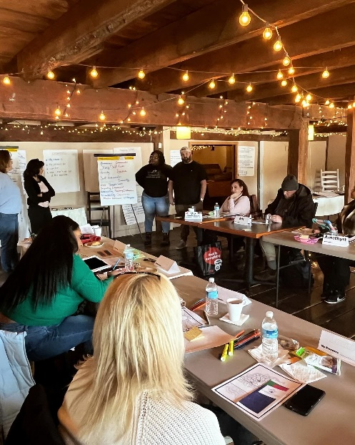
Certified Wellbeing Mentorship Course

This certificate course is co-facilitated solely by the Copeland Center team of international co-facilitators with several years of experience in the facilitation, consulting, and mentoring of others in wellness programming.
Participants will build on, enhance and advance their experience as Copeland Center Co-Facilitators using various educational curricula to conduct Copeland Center train-the-trainer courses and 1:1 mentorship in their community or agency.
Certification requires demonstration of prior co-facilitation experience via submission of evaluations, successful completion of a knowledge assessment, and mentoring.
This workshop is for individuals seeking to advance their skills, knowledge, and practices in promoting wellness, peer support, and community inclusion.
The course includes how to train co-facilitators in the new Taking Action for Whole Health and Wellbeing curriculum based on SAMHSA recovery materials.
Applicants shall have significant prior experience in co-facilitating groups following the values and ethics, and process a strong knowledge based on wellness, recovery, peer support, and community inclusion.

The Learning Objectives of this course will ensure that participants:

- Acquire advanced knowledge and skills in various evidence-based experiential strategies to co-facilitate wellness, recovery, and peer support education for individual and organizational wellbeing.

- Apply skills to train co-facilitators and mentor individuals in advanced co-facilitation approaches.

- Train co-facilitators to implement the Taking Action for Whole Health and Wellbeing course.

- Identify and describe the values, ethics, standards, and guidelines to implement evidence-based and experiential-based peer-to-peer wellness programs.

- Develop skills to mentor and lead teams and organizations to create workplace wellness.

